

ITINERARY AND PARTICIPANT INFORMATION

We are delighted that you are going to be travelling with us to the 2026 Tokyo Marathon.
We will have a very busy few days while we are in Tokyo, as you will read from the following itinerary. In addition to all the information in our itinerary you will find a further extensive set of information from KNT which includes, maps of the Expo and the registration area, a course map and detailed maps of the start and finish areas, a guide to your numbers, timetables for the race day, information about the Friendship Run and the After Run party, a map of the New Otani hotel and its surrounding area as well as a Tokyo map and Tokyo subway map.

There is a lot to take it but don’t worry the 2:09 Events team will be there to guide you through everything and answer your questions at any time.

BEFORE YOUR LEAVE FOR JAPAN

Visas and Vaccination certificates
Japan operates a visa-waiver scheme for UK and EU citizens so you don’t require a visa to enter the country. There are no vaccination requirements for Japan.

Learn a few basic phrases

All Japanese spend years studying English at school but struggle to speak it or understand it at all. However, they don’t expect anyone but Japanese to speak Japanese, so a few words will go a long way. As with any language there are different ways to say things but here a few basics.

Hello Ko nichi Wa (usually followed with a small bow of the head)
Thank-you Domo Ari gato (Or simply Domo or Ari gato will suffice in most cases)
Please Ku da sai (In shops just point to something and say Ku da sai)
Excuse me Su mi masen (use this to attract someone’s attention in a restaurant)

Although the written language is difficult – they use three different alphabets concurrently with more than 2000 characters in common usage - all the subway and train stations have English translations, as will all the key signs, particularly in connection with the marathon. Any bank or vending machine will have instructions in English. A lot of restaurants will have pictures of the food in the menu or plastic models in the windows. It may seem intimidating when you step off the plane because it is an alien environment to most westerners, but after the first day in Japan you will be surprised how easy it is to navigate the subway and train system, go shopping and move around Tokyo.

Bring some cash

The COVID pandemic has helped wean Japan off its obsession with cash and its reluctance to take credit cards, but it remains more of a cash society than the UK and other European countries. Credit cards are accepted in the hotel and most major shops and western restaurants but all local restaurants and shops generally prefer cash. If you use a multi-currency App like Revolut or Monzo, which comes with a card, you can move sterling, or a number of other currencies, into Yen at close to the interbank exchange rate. You can then use your card for most ATMs in Tokyo to withdraw cash for a small fee.

For travel around the subway, you can buy individual tickets but it’s better to use a pre-paid card. There are two options the Pasmo or Suica cards, which rather like a London’s Oyster cards are rechargeable smart cards that can be used on public transport and in some shops. Tourists can buy a Welcome Pasmo card on arrival at Haneda Airport that is valid for 28 days. The initial cost is ¥1500 (£7.50) and you need your passport to purchase one. You can top up the card in ¥1000 increments but you will lose any balance left on the card when you leave Japan or after 28 days whichever is the longer. Pasmo cards can be used on the subway or any of Tokyo’s trains, which integrate with the subway you can also use them to buy items from vending machines and in some shops. There is an alternative smart card system called the Suica, which works in the same way and is functionally the same as Pasmo. Both Pasmo and Suica cards can be purchased at mobile cards that sit on your phones and can be topped up and used through Apple Pay or the equivalents.

If you are going to do a lot of travel in a short period around Tokyo, you might consider a 24-hour or 48-hour subway card, which gives you unlimited travel around the subway network for ¥800 (£4) or ¥1200 (£6) respectively. These are staggeringly good value compared to London where that money would buy one or two journeys only. These tickets are only available to tourists so you’ll need your passport with a tourist stamp in it, to buy them and they are subway only. If you use one of the many overground trains you will need to pay separately by buying a ticket or tapping your Pasmo card.

YOUR 2:09 EVENTS REPRESENTATIVES

Steven Seaton will be staying at the Hotel New Otani for the duration of your trip. Steven is the Managing Director of 2:09 Events and was formerly the Editor and Publisher of Runner’s World Magazine. Having completed dozens of marathons and other races around the world, Steven is an experienced runner and traveler.

Steven lived in Tokyo for three years in his younger days so knows the city reasonably well, although it has changed a lot since then. He also speaks some Japanese, although less and less as the years go by. Steven has looked after our group in Tokyo for a number of years so he knows the event, the hotel and the race logistics reasonably well.

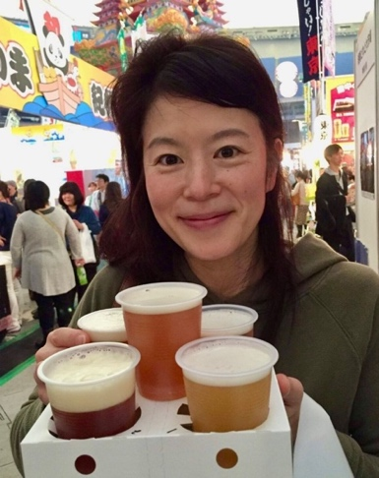

While you are in Tokyo Steven will be supported by our Japanese guide, Madoka Oizumi. Madoka, or Maddy as she likes to be called, is a professional guide and Tokyo resident who lived and worked in the UK for a number of years with her English husband. She has worked with our group for the last five Tokyo Marathons and is responsible for some of our ground arrangements in Tokyo. She will be with the group on Thursday and at the Friday evening and she will on the WhatsApp group to answer any questions you might have over the long weekend. It is also likely we’ll have another Japanese guide sent by KNT, the Japanese ground agent, on the arrival bus at Haneda airport.

Meet and Greets

Steven will be in the lobby of the New Otani Garden Tower to have a chat and answer any questions at the following times.

Friday February 28 10.30 am – 11.30 am
Saturday March 1 1.00 pm – 2 pm

If you need to contact him at other times you can do so through the hotel reception, by phone (+44 (0)7834 431000) or preferably by e-mail (steven@209events.com) Steven will also set up a WhatsApp group in the week before we travel which is a good way of sharing information and any last minute updates. We have a mobile number for the lead person who booked the trip, so we can automatically add that person to the WhatsApp group. If you would like others added just send Steven a note with the name and number. We’ll create the group in the week before and if for whatever reason you do not want to be included in the group, just drop Steven a note at the email address above and you will not be included. Please remember that the point of the group is for us to share information about the trip, update anything on the itinerary or the race or to ask questions. It is not a forum to express opinions of other subjects that are unrelated to the trip.

There will be plenty of other opportunities to see Steven if you need his help with anything: he will be meeting the group flights at Haneda airport on Thursday morning, leading a short run on Friday morning out towards the Imperial Palace and will be at the Friday night dinner amongst other things. If you have any questions before you travel just send him an email.

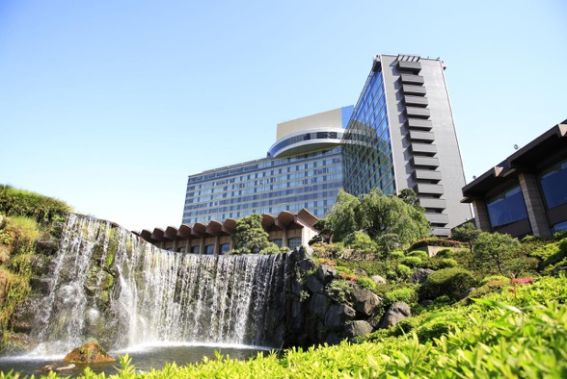

Your Hotel

A room has been reserved for you at the Hotel New Otani Garden Tower in the Akasaka area of Tokyo. The Hotel address is.

4-1 Kioi-Cho, Chiyoda-Ku, Tokyo, 102-8578
Tel: : +81 3-3265-1111
Website: http://www.newotani.co.jp

Surrounded by a beautiful 400-year old Japanese garden, the New Otani Tokyo Hotel is situated in central Tokyo and offers comfortable accommodation less than a 10-minute walk from 5 subway lines. It is a very large modern western style hotel with spacious rooms that include a flat-screen TV with satellite channels, a minibar and Wi-Fi. The hotel is so large it has two reception areas that are about five-minutes’ walk from each other. Our rooms are usually in the Garden Tower section of the hotel, which is on its east side. If you are travelling to the hotel outside our main group arrival or by public transport, the nearest subway station is Akasaka-Mitsuke, which is approximately a five-minute walk from the east side entrance to the Garden Tower.

Our accommodation is on a bed and breakfast basis. You will be given breakfast vouchers on arrival and those vouchers can be used in one of a number of restaurants within the hotel. Our group reservation starts on Thursday February 26 and we will not be allowed to check in before 4pm. The check-out time on departure is midday. If you are arriving individually on another day the check in time is 3pm.

Travel Details

Wednesday February 25, Thursday February 26

Haneda Airport Arrivals, Expo Visit, Sensoji tour

The international flight was not included in our travel package, however, many of you are using BA 0007, which leaves London on Wednesday February 25 at 09:05 and arrives at Tokyo Haneda at 07:35 the following day. Remember that Japan is 9 hours ahead of UK standard time, so you are effectively arriving late at night British time but at the start of the day in Japan. Try to sleep on the way out, jetlag is a considerable issue when travelling to Japan. Steven is arriving in Tokyo the day before but will be at Haneda airport to meet you on Thursday morning. When you have cleared customs look for the 2:09 Events sign and for Steven, who will be waiting in the arrivals hall along with Madoka, our Japanese guide who will be carrying a Union Jack flag. Both will be at the arrival hall at 8am. In the unlikely event that the plane is early and you come through customs before 8am, please wait for Steven and Madoka to arrive, although they will be monitoring the flight schedule.

In any case if you are the first out you may have a short wait before everyone clears customs, so please be patient. Some of you may have ordered Japanese SIM cards or mobile wi-fi devices, these can be picked up at the airport. You can also buy Pasmo or Suica travel cards at the machines close to the arrivals hall.
We have a private bus for our group but we still have to wait for everyone to clear customs before we start our mini Tokyo tour. The plan is to leave the airport around 9am and to stop at Yoyogi Park and Meiji Jingu before going to the Expo at Tokyo Big Sight soon after it opens at 10am. It is the first day of the Expo, it’s good to be first there. The queues for number pick up will be shorter and you might have a chance to find some official merchandise in a size that fits you. In recent years the Tokyo Marathon has been terrible with merchandise. There is very little of it and it sells out very, so the earlier we arrive the more chance you have of finding something to buy. All runners will receive an event T-shirt, which is to be picked up at the Expo and Asics Tokyo Marathon jacket, which Steven will hand out at the hotel.

We will stay at the Expo for at least two hours but if we need longer we’ll stay there. After the Expo we will drive to the north east of Tokyo to the temple complex of Sensoji, parts of which date back to the 7th Century. Part of the route to Sensoji uses roads that are part of the marathon course, which will give you an idea of what you will be running over on Sunday. There will be time to walk around the complex to buy some lunch or a do a little shopping before we get back on the coach to the hotel.

We realise that a few of you will already be in Tokyo when the main group arrives and a few will also be arriving on later flights on Thursday afternoon. Steven will escort a second group from the New Otani to the Expo at Tokyo Big Sight on Friday at 11.30am if required.

If you are travelling independently from Haneda airport to the New Otani Hotel, the easiest and quickest way, if the most expensive, is by taxi, which will cost around ¥8000-¥9000 (£40-£45). If you are feeling more adventurous start by buying a Pasmo card at the airport for ¥1500, then take the Express train on Keikyu Airport Line train from Haneda to Shimbashi. Shimbashi is a train stations and subway station. Transfer from the train station to the subway station. You have to tap your Pasmo card at the ticket barrier to leave the train station and follow the signs to the Ginza Line (A big G in an orange circle) and take the train in the direction of Shibuya. Shimbashi is (G08) on the Ginza line you should get off at Akasaka Mitsuke (G05).

From the subway station follow the signs to Akasaka- Mitsuke District Gate and head to Exit D and take the escalator to street level turn left over a small bridge and the entrance to the New Otani Hotel is on your left next to a car showroom. The entrance is on the first floor, the receptions for the hotel are on the 6th floor. The whole journey by train will less than an hour cost under ¥1000.

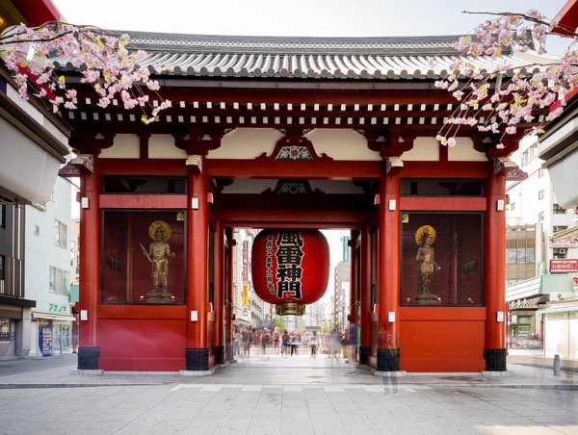

TOKYO MARATHON NUMBER PICK-UP & EXPO

The Tokyo Marathon Expo and number collection point is at Tokyo Big Sight South Halls, 3-11-1, Ariake, Koto-ku, Tokyo, 135-0063
The Expo is open 10:00 - 20:30 February 26 and 27
10:00 - 17:30 February 28.

To pick up your number you will need a photo ID and your race registration confirmation which should have been sent to your registered e-mail. The number pick-up process takes around 30 minutes and only runners are allowed into that area of the Expo, although your supporters are free to join you in the merchandising and shopping areas of the Expo. You have to pick up your own number, no one else can do this for you. In addition to your number you will be given a wristband, which you need to wear to access the start area on race day. Do not take this off after it is put on your wrist otherwise you may not be able to access the start area on Sunday morning. Note that you will need to bring your own safety pins, the organisers have decided that it is more sustainable for you to bring your own than for the race to provide them. Steven will have extra pins if you need them.

This year all ITP runners will be given an official check-in bag and baggage sticker, which you can use to check clothing, or a bag, at the start that can be collected from the finish. You have to use this bag if you are checking a bag at the start, no other bags are allowed.

Do not be alarmed by the reference in the Runner Handbook to the ‘Go/No Go Announcement’. Every event in Japan needs to consider what would happen in the event of an earthquake and has to have such a contingency. Also note that carrying a smartphone, which the race recommends in case of emergency, is not required, although you would be wise to carry a subway or Pasmo card.

As with any major marathon EXPO the Tokyo Marathon EXPO offers a plethora of shopping opportunities to replace any item of kit you may have forgotten to pack, although as noted already the official Asics merchandise sells out quickly. Of particularly note is the range of ‘official marathon’ merchandise. In past years this has included Tokyo Marathon chopsticks, fans and route map cookies. You’ll also have a chance to try the marathon’s official energy drink, the wonderfully named Pocari Sweat, which is served at a number of drinks stations on the course. You can also buy Pocari Sweat at more convenience stores and shops and it’s worth it before you run, it’s a light flavoured, inoffensive drink so should not be an issue.

If you are travelling to the Expo independently and you are starting at the New Otani Hotel, take the subway from Akasaka-Mitsuke using the Ginza line (G05) change at Shimbashi (G08). At Shimbashi transit to the Yurikamome line which is connected but different to the subway system – like the DLR in London – so you have to tap in again, Shimbashi Yurikamome line is U1, take it to Tokyo Big Sight (U11) which is the location of the Expo. Note that if you are using a 24 or 48-hour subway ticket, you can’t use it on the Yurikamome line. The Yurikamone line has driverless trains and if you can find a seat in the front carriage it’s cool ride as you head out through parts of Tokyo harbour.

For those visiting the Expo on our bus, we plan to be at Tokyo Big Sight for 120 minutes, which should be enough time to pick up numbers and do some shopping. We will then leave at midday to drive to Asakusa to visit Sensoji, with the goal of being at the hotel at 16:00 when we can check in. Steven will confirm with you whether you can check in individually or if it is a group check in, in which case he will collect and distribute all the keys from the KNT representative.

In addition he will also hand you an envelope with breakfast vouchers, your after-run party tickets (if you ordered one) and your transport bus patch, which you will need to board the bus to the start and from the finish on race day. If it’s an individual check in, the key and breakfast vouchers will come from the hotel staff. If you are arriving before Thursday February 26, your keys will be available from the hotel staff from 3pm, they will give you breakfast vouchers but the bus passes and post-race party tickets will come from Steven. Steven will hand out jackets later that evening or on Friday morning.

Friday February 27

7.30am For anyone who is interested, meet Steven in the lobby of the Garden Tower reception for a gentle run out towards the Imperial Palace and the gardens to the south of the park. This is close to Tokyo station and the finish of the marathon. This is an entirely optional run at a very gentle pace intended to blow away the cobwebs of jet lag. The run will be for a maximum of one hour and there will be a few stops along the way. The route around the Imperial Palace is circular and it’s 5km around, so you can extend or shorten the run as you see fit or go at a faster pace if you wish once we reach the outer Palace grounds. The total distance for the run is between 7-8K.

10.30am – 11.30 am Steven will be in the reception area to answer any questions and distribute after-party tickets and tour envelopes and jackets to anyone who has yet to collect them.

11.30am If you haven’t already picked up your number Steven will be leading another group to Tokyo Big Sight to the Expo.

6.00pm Meet in the lobby of the Garden Tower Reception in preparation for this evening’s group dinner at a local Japanese restaurant. We have booked a private room in a local restaurant called Banya. Our reservation is for 6.30pm. The restaurant is a short walk away from the hotel in the Akasaka- Mitsuke subway station area. We have ordered a set meal which will offer you the chance to try a variety of Japanese food. The meal and all drinks are included as part of your package so there is nothing to pay for. If for any reason you do not want to attend the meal, can you please let Steven know in advance. The dinner will be finished by 8.30-9.00pm at the latest. A number of you have notified us of your specific dietary requirements, which we have catered for at the meal. Please be aware that Japan is not a very flexible place and we won’t be able to change things on the night if you have specific dietary needs that you have not told us about in advance.

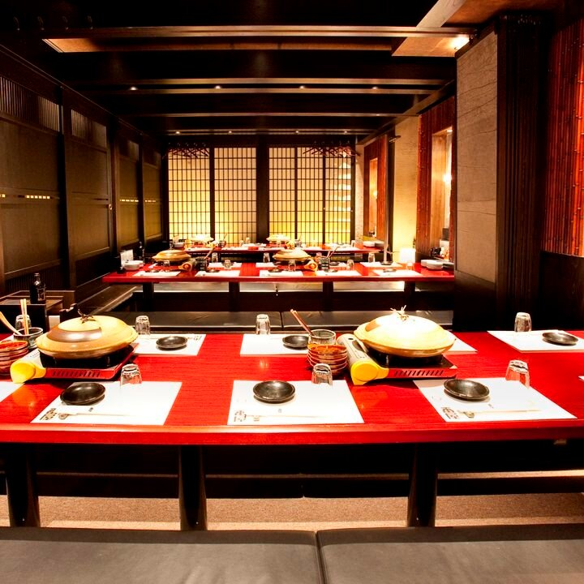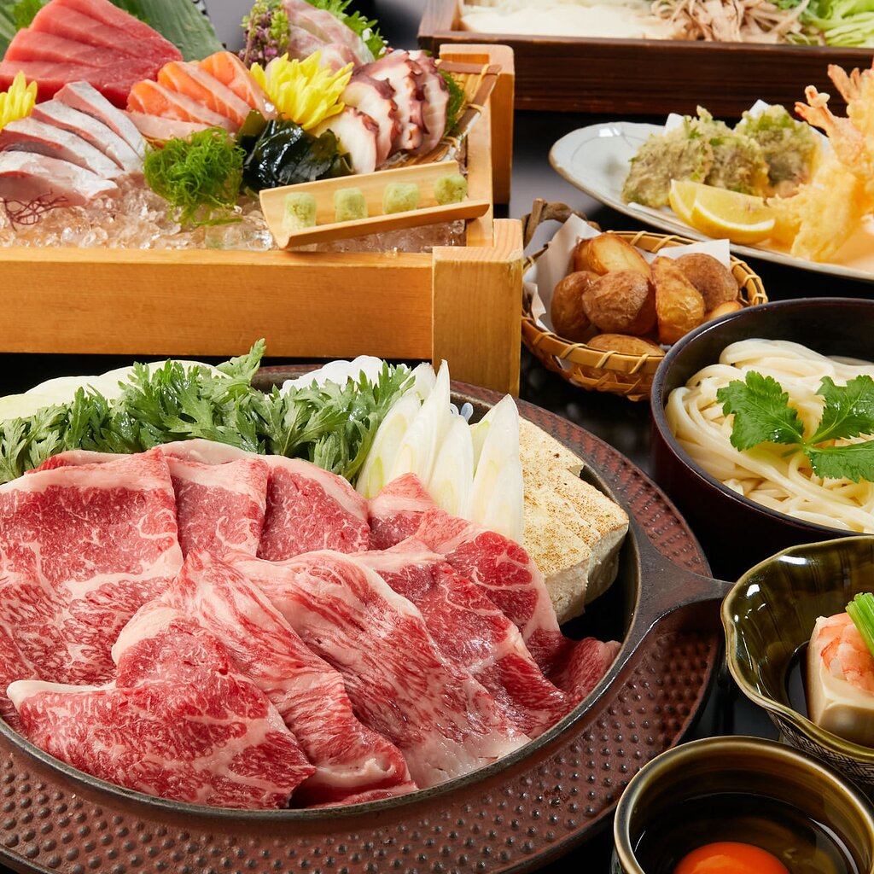

Saturday February 28

If you entered the Tokyo Marathon Friendship Run, it takes place this morning. There are three differently timed starts for the run. All our runners are starting on the second start at 11.30am, that means you should be at Taito Riverside Sports Centre in Sumida Park from 10.30am to register and pick up race numbers. It is a 5K Fun Run, which follows a route along both sides of the river with a crossing of the Sakurabashi Bridge. The closest subway station to Sumida Park is the Asakusa subway station (G19 on the Ginza Line). The easiest way to travel there is on the subway from Akasaka Mitsuke station (G05 on the Ginza Line). The subway section will take 25 minutes and the whole journey 45-50 minutes from the Hotel New Otani, so you should leave the hotel at 9.45 am to give you plenty of time to pick up numbers before the run.

If you have not entered the Friendship Run, you might consider one of Tokyo’s 5K Park Runs instead. Park Run is relatively new in Japan but the concept is the same as it is in the UK: a free, timed 5K every Saturday morning run by local volunteers. There are no runs in central Tokyo but a number in the inner suburbs. The easiest one to access from the New Otani is Futako Tamagawa. Park Runs in Japan start at 8am, so you will have to leave the hotel around 6.45am and take the subway from Nagatacho, which is about 10 minutes’ walk from the New Otani, taking the Dentoshi Line in the direction of Shibuya, which continues on to Futako Tamagawa station. It’s about 30 minutes on the train and the Park Run is 5-10 minutes from the station. Bring your personal bar code for your time, it works just the same in Japan.

1.00pm-2.00pm Steven will be in the reception of the Garden Tower to answer any questions and distribute after-party tickets and tour envelopes to anyone who has yet to collect them.

Sunday March 1

RACE DAY

05.30am The breakfast restaurants open at the Hotel New Otani for runners. Two of the restaurants should be open: The Garden Lounge and the Tower Buffet on the 40th floor. One of your breakfast vouchers is specifically for race day.

06.40am Meet Steven underneath the main reception of the Hotel New Otani, where all buses arrive and depart from the hotel, to catch the shuttle to the start. Remember to bring your shuttle bus sticker and attach it somewhere visible.

06.45am Shuttle buses start leaving the Hotel New Otani to take runners to the start area in Shinjuku. As the New Otani is one of the official race hotels there are dozens of different international running groups in the hotel as you will see on race morning. There will be dozens of buses shuttling runners to the start and we will try to take a late one. It is 20 -30 minutes to the start and even the last buses will arrive at the start before 7.30am.
Your entry gate and baggage truck number are printed on the front of your race number, which for ITP runners are Purple.

Remember the clear plastic official bag if you want to check a bag at the start. They do not issue replacements so if you do not have it you will not be allowed to check a bag. It can be quite cold at the start at this time of year in Tokyo, so we would advise you to wear some warmer clothes to the start and use the checked bag option. The Tokyo Marathon tries to discourage anyone from wearing old clothes and discarding them at the start/finish area so whatever you are wearing you will have to run in if you don’t check a bag. Please pay attention to the banned products in the start area, particularly hydration packs, plastic drinks bottles or bum bags which you cannot take into the start. The runner information suggests you carry your mobile phone for emergencies but it is not obligatory and simply carrying a Pasmo or Suica card would suffice if, for whatever reason, you had to drop out and make your way back to the hotel by subway.

07.00am For anyone who does not want to or could not take the shuttle bus, Steven will escort them to the start by subway. It is approximately 15 minutes on the Marunouchi line from Akasaka Mitsuke to Nishi Shinjuku, which is a further 5-10 minute’s walk to the start gate. The shuttle buses are an easier option.

08.45am Any spectators or supporters can meet Steven in the reception of the Garden Tower. We will be taking the subway to a couple of key points on the course around Asakusa at 20K and then back towards the Ginza area at 35K. The precise point will depend on other crowds in the area. From the Ginza area, supporters can easily walk back to the finish near Tokyo station to see your runners in the last kilometre before meeting up after they have completed their race. Both spectators and runners can meet after the finish to take the shuttle bus back to the hotel together.

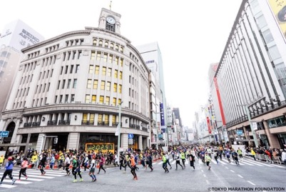

09.10 am Start of the 2026 Tokyo Marathon

11.30 am – onwards The marathon finishes in front of Tokyo Station on Hibiya Dori, which is to the south of the Imperial Palace. You will be presented with your finishers medal and a poncho to keep you warm. Now follow the Purple colour coded route away from the finish and towards the shuttle bus bringing you back to the New Otani. You should still have your Race Day Transfer patch, which is colour-coded for the buses going to Akasaka – Shinjuku area (orange). The buses will leave every 30 minutes from 12:00 to 16:30.

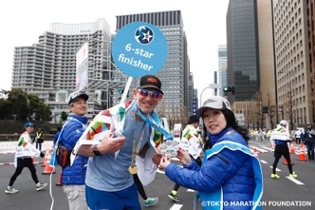

For those who are pre-registered that they are completing their Abbott WMM six star journey at Tokyo, the presentation of your six-star medal will happen at the end of the marathon and there are signs after you cross the finish line directing you to that collection point. The six-star finisher programme is administered by Abbott, the sponsor of the Marathon Majors. There is usually a secondary ceremony at the After Run Party to celebrate six-star finishers.

5:00 pm The After Run party takes place at a location called Hapoen and has two editions. Our tickets are for group one, which has a shuttle departure from the New Otani between 5-5:15pm. It is approximately 30 minutes by bus to the party location. The party ticket includes all food, drink and entertainment of which there are multiple options over multiple floors of Hapoen. The party is organized by KNT, our Japanese ground agent, and caters only for international runners. There will be short ceremony at the party for those finishing their 6-star journey at this year’s Tokyo Marathon. The party lasts for two hours and shuttles back to the New Otani will start to depart from Hapoen at 19:30.

Monday March 2

You have had a busy few days in Tokyo and after the exertions of the marathon, this is a day to take it easy and relax and perhaps explore a little of Tokyo you not have yet seen. There are no activities scheduled for today.

Tuesday March 3

DEPARTURES

For those of you departing today on BA006 to London Heathrow the flight now leaves Tokyo Haneda on March 4 at 9.45am, and we’ll be leaving reception of the Garden Tower at 06am. Please make sure you have checked out and settled any outstanding bills in advance. As we are leaving before the breakfast restaurants open, the hotel will provide a breakfast box. The bus will depart for Haneda airport at 06.15am from the bus area underneath the main hotel reception. You will be at the airport around 7am

The 2:09 Events trip to the Tokyo Marathon officially ends on March 3, although quite a number of you have decided to stay on longer we won’t have staff on site to help you after that point.

